WEEK 4 ROLL NO:230701304

PROGRAM 1:

import java.util.Scanner;

import java.io.\*;

class arr{

public static void main(String[] args){

Scanner scan= new Scanner(System.in);

int n=scan.nextInt();

int a[]=new int[n-1];

for(int i=0;i<n-1;i++){

a[i]=scan.nextInt();

}

for(int i=0;i<n-1;i++){

for(int j=i+1;j<n-1;j++){

if(a[i]>a[j]){

int temp=a[i];

a[i]=a[j];

a[j]=temp;

}

}

}

for(int i=0;i<n-1;i++){

if(i+1==a[i]){

continue;

}

else{

System.out.print(i+1);

break;

}

}

}

}

OUTPUT:

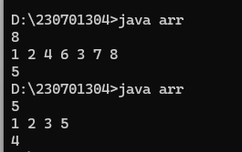

PROGRAM 2:

import java.util.\*;

import java.io.\*;

class zero{

public static void main(String[] args){

Scanner scan= new Scanner(System.in);

int n=scan.nextInt();

int a[]=new int[n];

for(int i=0;i<n;i++){

a[i]=scan.nextInt();

}

int c=0;

for(int i=0;i<n;i++){

if(a[i]!=0){

a[c]=a[i];

c++;

}

}

while(c<n){

a[c]=0;

c++;

}

for(int i=0;i<n;i++){

System.out.println(a[i]);

}

}

}

OUTPUT:

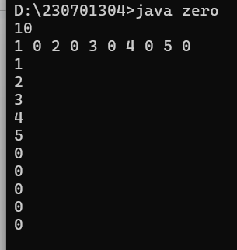

PROGRAM 3:

import java.util.Scanner;

import java.io.\*;

class row{

public static void main(String[] args){

Scanner scan= new Scanner(System.in);

String s=scan.nextLine();

int currentValue=0,total=0,prev=0;

for (int i = s.length() - 1; i >= 0; i--) {

char currentChar = s.charAt(i);

switch (currentChar) {

case 'I':

currentValue = 1;

break;

case 'V':

currentValue = 5;

break;

case 'X':

currentValue = 10;

break;

case 'L':

currentValue = 50;

break;

case 'C':

currentValue = 100;

break;

case 'D':

currentValue = 500;

break;

case 'M':

currentValue = 1000;

break;

}

if (currentValue < prev) {

total -= currentValue;

}

else {

total += currentValue;

}

prev=currentValue;

}

System.out.println(total);

}

}

OUTPUT:

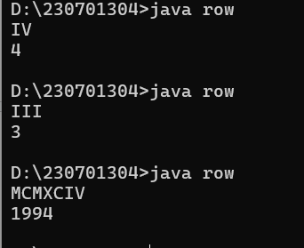

PROGRAM 4:

import java.util.\*;

class Palindrome {

public static void main(String[] args) {

Scanner scan = new Scanner(System.in);

String s = scan.nextLine();

String r = "";

String p = "";

s = s.toLowerCase();

for (int i = 0; i < s.length(); i++) {

char ch = s.charAt(i);

if (ch >= 'a' && ch <= 'z') {

r += ch;

}

}

int n = r.length();

for (int i = 0; i < n; i++) {

p += r.charAt(n - i - 1);

}

if (p.equals(r)) {

System.out.println("True");

} else {

System.out.println("False");

}

}

}

OUTPUT:

